Iris Flower Classification Project using Machine Learning

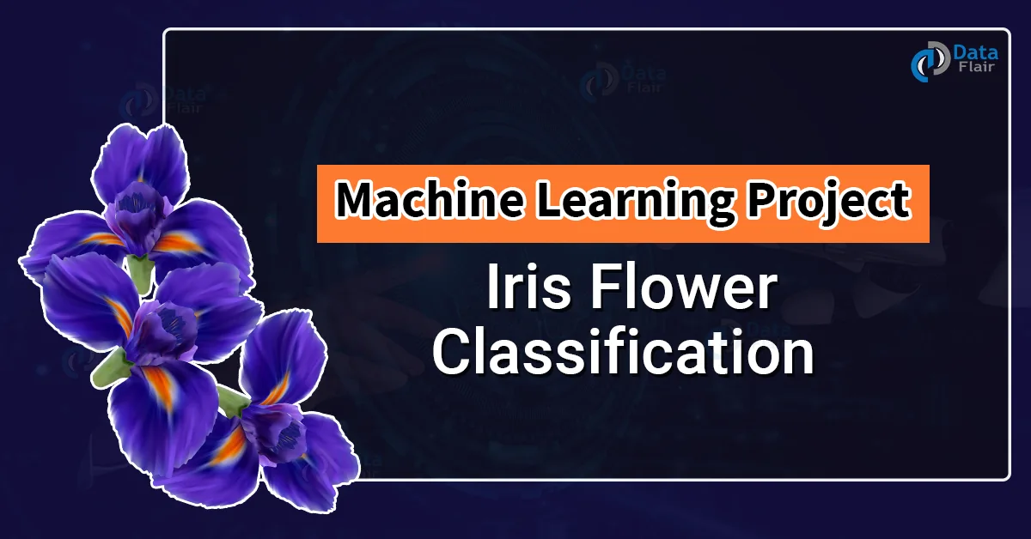

Machine learning is almost everywhere nowadays. It’s become more and more necessary day by day. From the recommendation of what to buy to recognizing a person, robotics, everywhere is machine learning. So in this project, we’ll create the “Hello World” of machine learning which means Iris flower classification.

**Iris flower classification** is a very popular machine learning project. The iris dataset contains three classes of flowers, **Versicolor, Setosa, Virginica,** and each class contains 4 features, ‘Sepal length’, ‘Sepal width’, ‘Petal length’, ‘Petal width’. The aim of the iris flower classification is to predict flowers based on their specific features.

Steps to Classify Iris Flower:

**What is This Project About?**

This project uses a computer program to identify different types of iris flowers based on their features, like the length and width of their petals and sepals

(the green leaves under the flower).

**Why is This Important?**

Classifying flowers helps scientists understand plant species better and can be useful in gardening, farming, and environmental studies. This project shows how computers can learn to recognize patterns, just like we do!

**How Does It Work?**

1. **Data Collection**: We start with a special collection of data called the Iris dataset. It has information about 150 flowers, including their measurements and species (types).
2. **Visualizing Data**: We create colorful charts to see how the different flower types compare to each other based on their features. This helps us understand the data better.
3. **Training the Model**: We teach a computer program (called a Decision Tree) using some of the data. This is like showing a student examples until they can recognize the differences.
4. **Testing the Model**: After training, we check how well the computer program can identify the flower types using new data it hasn't seen before.
5. **Results**: Finally, we see how accurate the program is and display the results in a clear way.

**What Did We Learn?**

By the end of this project, we can predict what type of iris flower it is just by looking at its measurements! This project shows how we can use computers to solve problems and make predictions in real life.

**How Does the Project Work in Details ?**

Here’s a step-by-step breakdown of what we do in the project:

* **Step 1: Load the Dataset**: We start by loading the iris dataset into our program. This data is like our textbook filled with examples.
* **Step 2: Visualize the Data**: We create graphs and charts to see the data visually. This helps us understand the differences between the flower species and observe patterns.
* **Step 3: Split the Data**: We divide the dataset into two parts:
  + **Training Set**: This part is used to teach our model how to recognize the flowers.
  + **Testing Set**: This part is used to check how well our model learned.
* **Step 4: Train the Model**: We use a machine learning algorithm called a **Decision Tree**. It learns by making decisions based on the features of the flowers. For example, it might first check the petal length to decide whether a flower is likely to be Setosa or not.
* **Step 5: Make Predictions**: Once the model is trained, we test it with the testing set. The model tries to predict which species each flower belongs to.
* **Step 6: Evaluate the Model**: Finally, we check how many predictions were correct. We can also create a confusion matrix, which is a special table that helps us see where the model made mistakes.

**What Do We Learn from the Results?**

After running the program, we can see:

* **Accuracy**: This tells us how many predictions the model got right. For example, if the model correctly identifies 90 out of 100 flowers, its accuracy is 90%.
* **Confusion Matrix**: This helps us understand which flowers were confused with each other, giving us insights into how the model can be improved.

**Conclusion**

The Iris Flower Classification project is a great way to learn about machine learning and data analysis. It shows how we can use data to teach computers to make decisions, just like humans do. By the end of the project, not only can we identify different types of iris flowers, but we also learn valuable skills in programming, data handling, and critical thinking.

**Key Takeaways**

* **Machine Learning**: A method where computers learn from data.
* **Data Visualization**: Using charts to make sense of data.
* **Model Training and Testing**: Teaching a model and checking its performance.
* **Real-World Applications**: Understanding plant species can help in various fields.

**There are several exciting ways you could expand and enhance the Iris Flower Classification project in the future. Here are some ideas to consider:**

**Deploy the Model**

* **Web Application**: Create a web app using frameworks like Flask or Django, allowing users to input measurements and get predictions about the iris species.

**Add Data Visualization**

* **Interactive Dashboards**: Use libraries like Plotly or Dash to create interactive visualizations that allow users to explore the dataset and model predictions dynamically.

**Collaborate with Others**

* **Open Source Collaboration**: Share your project on platforms like GitHub and invite contributions from others to enhance the project.
* **Educational Workshops**: Organize workshops or tutorials to teach others about machine learning using your project as an example.

**Explore Different Datasets**

* **Classify Other Plants**: Find and classify other types of flowers or plants using similar techniques, broadening the scope of your project.
* **Multiclass Classification**: Investigate other datasets that contain more than three classes to tackle more complex classification tasks.